Performance

**General**

**Performance legislation**

Class A: > 9 seats OR MTOM > 5700 kg | Jet + Turboprop → engine failure must be considered at all stages of flight

Class B: ≤ 9 seats | MTOM < 5700 kg | Propeller → engine failure is not assumed < 300 ft

Class C: > 9 seats OR MTOM > 5700 kg | Piston

For all classes of aircraft calculating the takeoff distance, no more than 50% of HW and no less than 150% TW is assumed

**Definitions**:

* **Measured performance** is the performance achieved by the manufacturer under test conditions for certification
* **Gross performance** is the fleet average of airplane performance that must be respected across the board if sufficiently maintained and flown in relation to a series of techniques found within the manual. These techniques allow for all airplanes to operate via the same margins
* **Net performance** is the gross performance diminished to allow for various contingencies that cannot be accounted for operationally.
* The **Safety margin** required for public transport, is based on the probability of an event/incident/accident being less than 1 in 1 million. Statistically this is known as a remote probability.

Net takeoff distance > Gross Takeoff distance > Measured takeoff distance

Net landing distance > Gross landing distance

Net descent gradient > Gross descent gradient

Net = Gross + safety margin | note: Gross > Net (safety margin is negative)

**Gross performance is actual flight performance with NO safety margin**

**Net is gross reduced by safety margin**

Earlier point at which wheel brakes may be applied by the pilot: when only the main wheels are firmly on the ground, provided the nose gear can be lowered in a controlled manner

**Impingement drag**: due water striking the landing gear and airframe

**Displacement drag**: resisting forward movement of the wheels



Wet ice: ice with a layer of water (any depth) on top of it or ice that is melting

Compacted snow: snow compresses into a solid mass such that airplane tires will run on it without further compaction of the surface

**General performance theory**

**Density altitude** is pressure altitude corrected for ‘’non-standard’’ temperature

**Density altitude increases** if pressure ↓ and temperature ↑

**Absolute ceiling** is the altitude at which the theoretical rate of climb, with all engines operating at maximum continuous power, is reduced to zero feet per minute.

**Specific Fuel consumption:** Fuel flow/Power [Prop] | Fuel flow/Thrust [Jet]

**Specific Air Range [SAR]** = TAS/Fuel burn [if ‘’Specific Range’’ is used, they are referring to SAR]

**Specific Ground Range** **[SGR]** = GS/Fuel burn

Climb angle = horizontal plane – flight path | Descent angle = horizontal plane – flight path

Climb gradient (%) = distance travelled/altitude gain | Descent gradient (%) = distance travelled/altitude loss

Flight path angle = horizontal plane – velocity vector | increases during climb in a HW

Flight path gradient = corrected flight path vector over the ground and the altitude gained

The **climb/descent angle** refers to the **angle** of the aircraft **relative to the air mass** the aircraft is climbing or descending in

The **flight path angle** refers to the **angle relative to the earth’s surface**, and is therefore **dependent on HW or TW**

**Wind effective gradient (%) = ROC (ft/min) ÷ GS (kt)**

When ↑ OAT - Mass - Pressure altitude (altitude) → Climb Gradient – ROC – Climb angle ↓

When in a HW → Flight path angle ↑ and Ground distance ↓ [same ROC but less ground distance flown = higher FPA]

**VX** is the speed for the best gradient or angle of climb → greatest altitude gain in the shortest horizontal distance

It is the speed obtained at the biggest difference between Thrust available and Thrust required

**VY** is the speed for the best rate of climb → greatest altitude gain in the shortest time

**In a OEI situation:** VX < VXse < VYse < VY

When **flaps and slats are retracted**, VX and VY ↑

Heavier and lighter airplane glide the same distance, but it takes different time and heavier airplane is faster to reach it.

Heavier aircraft has a greater glide angle and ROD

The parameter affecting gliding distance is wind: HW reduces it, TW increases it

A frangible obstacle is classed as an obstruction in the takeoff path that is a minimum hazard to an aircraft

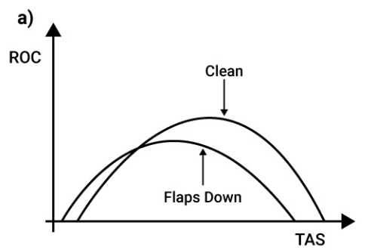

**Runway definitions:**

* Clearway [CWY]: an area beyond the paved runway, free of obstructions and under the control of the airport authorities at least 150 m wide (500 ft).
* Stopway: an area beyond the runway which can be used for deceleration in the event of a rejected takeoff. It is identified by large yellow chevrons on either end of the main runway. It shall be:
  + At least as wide as the runway
  + Centered upon the runway centerline
  + Capable of supporting the airplane during an aborted takeoff without causing structural damage to the aircraft
  + Designated by the airport authorities for use in decelerating the airplane during an aborted takeoff

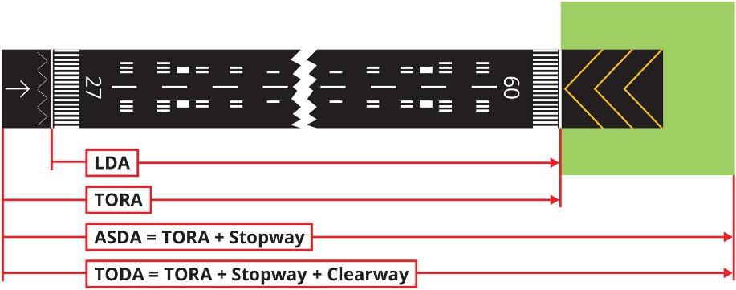

* Screen height: an imaginary barrier, located at the end of TODA or the beginning of the LDA.
  + TODA Class A = 35 ft (15 ft if wet)
  + TODA Class B = 50 ft
  + LDA all classes = 50 ft

Turns are not permitted after takeoff < 50 ft or if half-wingspan > 50 ft, the half-wingspan length

If CWY > 50% TORA → TODA = TORA x 1.5

Example

TORA = 2000 ft → 50% TORA = 1000 ft

CWY = 1200 ft > 50% TORA

TODA = TORA x 1.5 = 3000 ft

**Variables influencing performance**

* Pressure altitude
* OAT
* Winds
* Weight ↑
* - Configuration
* - Anti-skid system
* - Airplane CG
* - Runway surface and slope

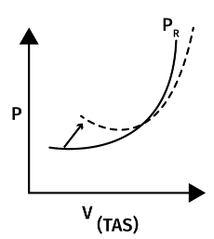

Mass ↑

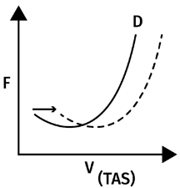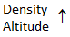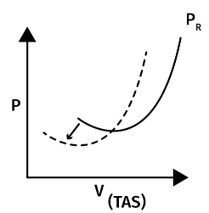

Altitude ↓

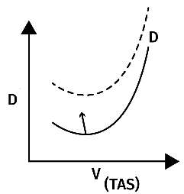

Gear ↓

Many jet engines are **flat rated (flex takeoff)**, that is, they are restricted to a maximum thrust even though the engine can produce higher thrust. The reason being that at lower temperatures **too much thrust may be generated** and the pressures within the compressors may be exceeded. For this reason an assumed or **flex temperature**, higher than the actual temperature, is used. It is **not an operational limit**. In a flex takeoff **TOGA is available.**

A **derated thrust** setting is considered to be a limit (as per AFM) and TOGA cannot be selected

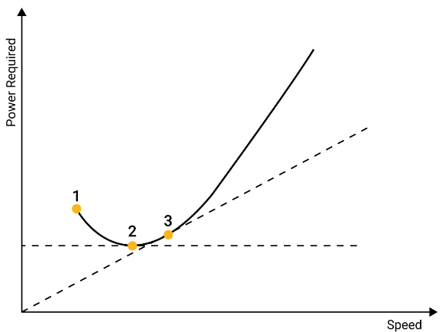In the Power Required vs Speed curve the points are:

1. Takeoff/Climb
2. Max Endurance (Cruise) VMP, VX, Max endurance
3. Max Range (Cruise) VMD, VY, Max range [= VMD in Drag curve]

In a Power/Thrust required vs TAS:

* Lowest point for JET is VMD­
* Tangent from origin JET is = Max Endurance = 1.32 VMD
* Lowest point for PISTON is VMP = Max Endurance = Min Power
* Tangent from origin PISTON is = Max Range = VMD

VMP ↑ as altitude ↑ as power required ↑ [Power = Drag * TAS]

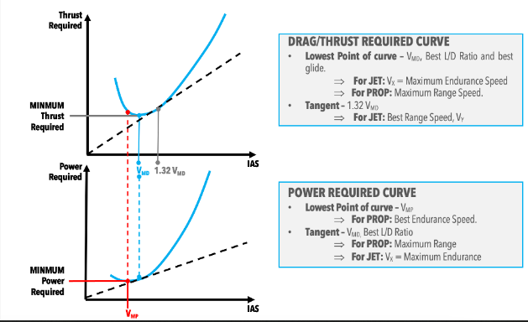

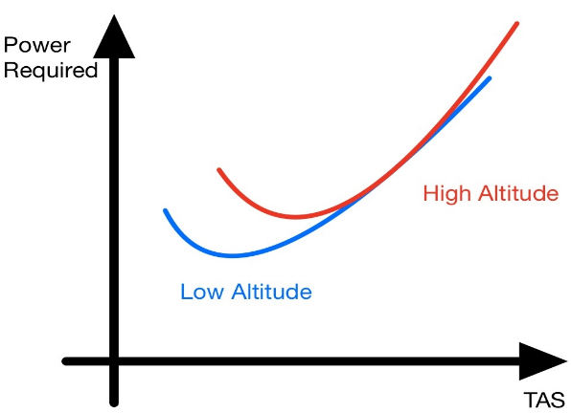

Prop engines

**Correction factors**

+5% takeoff distance each +1% of upslope

On a Dry runway V1 ↑ and ASDA ↑ by uphill slope

Correction factors Class B:

* Landing: Grass = 1.15 | Wet paved = 1.15

Dynamic hydroplaning [rotating tire – takeoff]: $9*\sqrt{PSI}$

Viscous hydroplaning [non-rotating tire – landing]: $7.7*\sqrt{PSI}$

Gradient (%) = 100 * Glide slope (°)

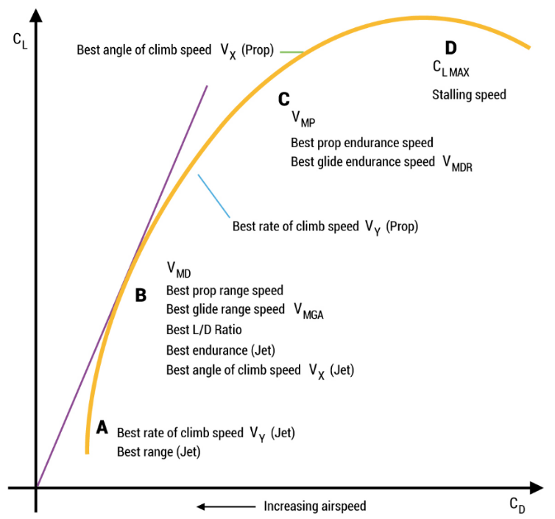**Level Flight, Range and Endurance**

Max Range = ${\left(\frac{TAS}{Drag}\right)}_{MAX}$

|  |  |  |
| --- | --- | --- |
|  | Max endurance | Max range |
| Propeller | VMP | VMD |
| Jet | VMD | 1.32 VMD |

**Max endurance** is reached at:

* Prop: sea level
* Turbo prop: about 10000 ft
* Jet: high altitude

For a propeller airplane, SFC and SRG increases until the increase in the GS is offset by the increase in power required. The increase in power required, caused by an increasing TAS in the climb, offsets the gains in SFC and SRG as you climb.

SFC = FF/Thrust | Specific range = NM/kg | Specific Endurance = 1/FF

VS1g (CLmax)means the 1-g stall speed at which the airplane can develop a lift force (normal to the flight path) = weight.

In OEI, Thrust required increases, Thrust available reduces by 50% and Excess Thrust decreases by more than 50%

**Climbing**

The climb gradient is always larger than the angle of climb (5% climb gradient ~ 3° angle of climb)

**GC (%) = sinγ * 100** | **γ = tan-1**(**altitude gain/distance flown)**

**Gradient = ROC/TAS | Gradient = ROC/GS**

Climb gradient is dependent on Thrust: (TReq - TAva)/W

ROC is dependent on Power: (PReq - PAva)/W

During climb, the max angle of climb is achieved when flying with the minimum thrust required, so that the excess thrust is maximum and is used to increase the climb angle.

During a climb, in an engine failure VY ↓ and rate of climb ↓ [VYse < VY]

VX and VY (TAS) ↑ as altitude ↑, because IAS = ρ*TAS and if IAS = constant and ρ ↓ then TAS has to ↑

Best climb performance is achieved with small angle of flap and slat

If weight ↑, VX (best angle of climb speed) and VY (best rate of climb speed) ↑

**Height difference (ft) = [Ground distance (ft) x Climb gradient (%)/100] x TAS/GS**

**Obstacles clearance (ft)** = Height difference + 50 ft (to account for screen height) – obstacle height

**Descent**

In a glide:

* Descent gradient = constant
* Rate of descent ↓ as you descend

If an aircraft is heavier than another, the minimum glide angle is constant, but airspeed varies

**CS-23 | Class B - Theory**

|  |  |  |
| --- | --- | --- |
| MEP | | |
| VR | 1.05 VMC | 1.1 VS1 |
| V2 | 1.1 VMC | 1.2 VS1 |
| VREF | > VMC | 1.2 VS0 |

|  |  |
| --- | --- |
| SEP | |
| VR | ≥ VS1 |
| V2 | 1.2 VS1 |
| VREF | 1.3 VS0 |

In the event of an engine failure:

* the airplane should be capable of reaching a point (1 000 ft above the intended landing area) from which a safe forced landing can be made
* no cloud < MSA
* most favorable situation is wind coming from the live engine side (due to aircraft weathercocking)
* VMC ↑ if altitude ↓

Obstacles are considered if they lie in an area called the "**Obstacle Accountability Area**":

* Wing span > 60 m: ½ wing span + 90 m + 0.125*D is the semi-width to be used
* Wing span < 60 m: ½ wing span + 60 m + 0.125*D is the semi-width to be used.
* The area expands from the appropriate semi-width, at the rate of 0.125 x D (Distance from end of TODA)
* In VFR is effectively substituted by ensuring the weather conditions during operation are sufficient to visually navigate and avoid obstacles

The take-off climb extends from 50 ft above the surface at the end of TODR to 1500 ft above the same surface

Minimum speed on takeoff at the screen height of 15m/50ft is a "safe speed" or 1.2 VS1

Minimum speed on landing VREF = 1.3 VS0

VREF is the Landing Reference Speed at a point 50 feet above the landing threshold

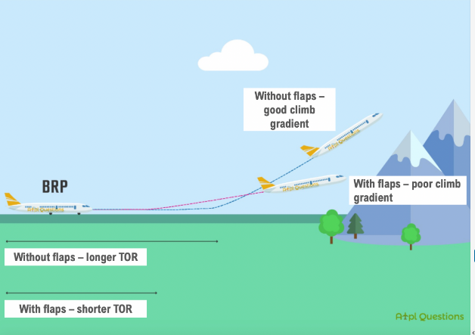

Balk landing minimum climb gradient: 2.5% (class B) | 3.2% (class A)

Missed approach minimum climb gradient: 0.75%

Runway length requirements:

* Unbalanced (stopway or clearway)
  + ASDA ≥ TOD x 1.3
  + TODA ≥ TOD x 1.15
  + TORA ≥ TOD
* Balanced (no stopway or clearway)
  + TORA ≥ TOD x 1.25

Rolling takeoff allows the airplane to accelerate slowly as the power is applied to the engines. TOD and ASD both increase

After takeoff when there are close-in obstacles, using a lower flap increase TODA, but improve the climb gradient

For takeoff wind considerations are as follow:

* Headwind component: ≤ 50%
* Tailwind component: ≥ 150%

For descent problems: Net gradient (%) = Gross gradient (%) + 0.5%

Still Air Distance = Height Difference/Net Gradient (%) x 100

Net glide distance = Ground distance = Still Air Distance x GS/TAS

Descent gradient (%) = (1/(L:D)) * 100

Exercise explained:

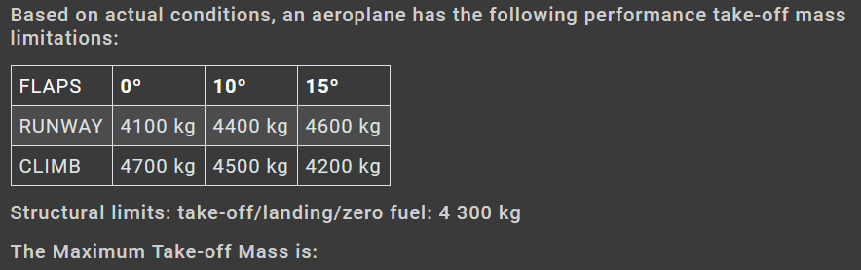

* For each flap setting choose the lowest value (most limiting):
  + 0° = 4100 kg
  + 10° = 4400 kg
  + 15° = 4200 kg
* Choose the highest value between the remaining options: 10° = 4400 kg
* Check such value against the structural limit (4300 kg) and choose the most limiting one: 4300 kg

**CS-23 | Class B – Use of performance data for SE and ME airplanes**

**Gradient = ROC/TAS**

**Height gained =** Gradient (%) x Distance travelled/100

When given a LDA, use 70% (1.43) of it as Max Landing Distance Required (LDR) because we assume not to use the full LDA.

The Landing distance found in the CAP is the gross LDR (without correction factors)

Net LDR = Gross LDR * correction factors [remember to include 1.43 to factor LDR ≤ 0.7*LDA]

Factored = LDR*safety factors

Defactored = LDR / safety factors

Barrier speed = VREF = 1.3 VS0

**Vertical distance from obstacle on takeoff (no cloud base)**

$Height difference \left(ft\right)=\frac{Ground distance \left(ft\right)*Climb gradient\left(\%\right)}{100}*\frac{TAS}{GS}$

$Obstacle clearance \left(ft\right)=Height difference+50 ft-Obstacle height$

**Vertical clearance from obstacle on takeoff (with cloud base)**

1. $Horizontal Distance \left(HD\right)=\frac{Cloud Base - 50}{ROC*0.77}*\frac{GS}{60}$ [NM]
2. $Residual Distance \left(RD\right)=Obstacle distance-HD$ [NM]
3. $Height gain=\frac{RD}{GS}*ROC_{(OEI)}*60$ [ft]

$Clearance=Cloud base+Height Gain-Obstacle Height$

**CS-25/Applicable Operational Requirements Performance Class A – Theory**

**Takeoff**

**Contaminated runway**:

* surface water more than 3 mm deep, or by slush, or loose snow
* compacted now
* ice (including wet ice)

**Wet runway** = covered in water + shiny appearance + no significant areas of standing water

**Damp runway** = not dry + not a shiny appearance

On a wet runway, TODA ↑ and ASDA↑ too due to reduced braking friction coefficient (consequently V1 ↓)

**Balanced runway**: TODA = TORA = ASDA or TODR = ASDR | **Unbalanced runway**: TODR < ASDA

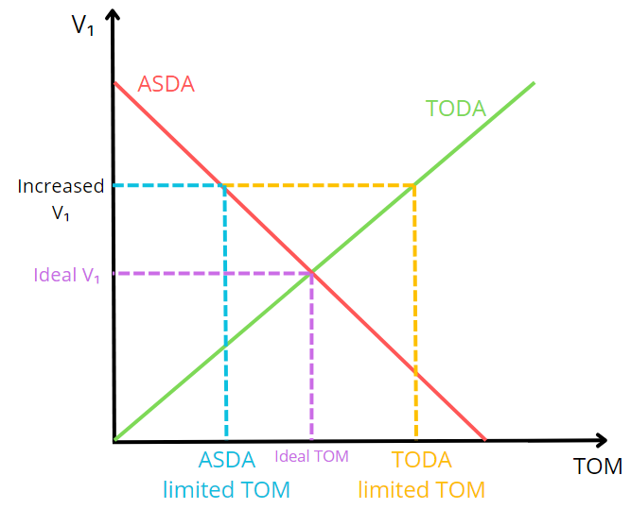TODR = ASDR = V1 Balanced (ASDA = engine failure TOD)

**Adding Stopway**: MTOM and V1 ↑

**Adding Clearway**: MTOM ↑ but V1 ↓

**Runway with upslope:** TODA↑ but ASDA ↑ too because the negative effect on acceleration is larger than the positive effect on deceleration in case of an RTO, thus both distances increase

If V1 ↑, MTOM ↑ when limited by TODA

If V1 ↑, MTOM ↓ when limited by ASDA

V1 is limited by VMCG because if V1 is too low, we have not enough authority on the rudder, so V1 ≥ VMCG

If a lower V1 is wrongly used in the FMC and a failure occurs after such V1, the TODR will be longer than the one calculated originally with the right higher V1

If a higher V1 is wrongly used in the FMC and a failure occurs after such V1, the ASDA may exceed the one calculated originally with the right higher V1

**Lineup loss**

* doesn’t change V1 as it’s more convenient to reduce mass, to avoid obstacle clearance problems in the event of an engine failure (if we reduce V1, we reduce the obstacle clearance at screen height).
* TODA, ASDA, TODA doesn’t account for lineup losses.
* Accountability is required for a 90° - 180° entry/turnaround to the runway.

Reducing the rotation rate on takeoff will ↑ TODA and TORA, but ↓ obstacle clearance

V2MIN is limited by the VSR at high (density) altitude | V2MIN ≥ 1.13VS1/SR (all jet) | V2MIN ≥ 1.08 VS1 (+3 engines turboprop)

V2MIN is limited by the VMC at low (density) altitude | V2MIN ≥ 1.1 VMC

V2 ↑ as air density ↑ (more asymmetric thrust)

The **increased V2 procedure** aim to improve the TOM and still attain the required climb gradient. To do so the airplane is hold on the runway on the ground until it reaches an **increased VR (and V1)**, climbing at an increased V2 near or equal to VX­

VSR doesn’t depend on air density

Reverse thrust is NOT included in a dry runway when calculating ASDA

Reverse thrust is included in a wet runway when calculating ASDA

**Climb limited takeoff mass** ↑ if flap ↓ and V2↑ because:

* reducing flap increase climb gradient
* V2 < Vx (best angle of climb speed), so the higher V2, the better the climb gradient too

**Flex** takeoff thrust (**reduced thrust**) is used to decrease the engine performance. TOGA is available if needed.

**Derated** takeoff thrust (**reduced maximum thrust**) doesn’t allow to go over a certain preset thrust, even if 100% throttle is used.

To avoid a pilot overreaction (selecting TOGA too late with risk of runway excursion), Flex (reduced) takeoff thrust is NOT allowed on contaminated runways. Derated is allowed on contaminated and wet runways.

The primary advantage of the derated thrust takeoff, compared to flex takeoff, is that the lower rated thrust will lead to lower values of VMCG and VMCA and this fact may avoid a VMCG limited takeoff, in some circumstances, leading to a greater MTOM at a lower thrust setting.

Final takeoff speed VFTO > 1.18 VSR and needs to provide at least the gradient of climb required

Tire speed limit major parameters are: Rotation rate of the tire and temperature (tire is filled with dry nitrogen, not air)

**Net Take-off Flight Path (NTFP)** is divided in 4 stages:

* **Segment 1** starts at the screen height, 35ft above the reference zero point at V2 and ends when the gear retraction is completed.
* **Segment 2** is flown at V2 to a minimum of 400 ft gross, known as the acceleration altitude. It is assumed 1 engine out climb from this segment (from VEF = the speed at which the Critical Engine is assumed to fail during takeoff)
* **Segment 3** is flown level while accelerating and retracting flap on schedule to VFTO, the final take-off speed which cannot be less than 1.18 VSR or a safe maneuvering speed.
* **Segment 4** is flown with Maximum Continuous Thrust from 400 ft to ≥ 1500 ft, where the aircraft is said to be en-route

The NTFP requires a 35 ft obstacle clearance for class A (as per segment 1)

If a bank > 15° is needed, the required obstacles clearance margin is increased from 35 ft to 50 ft

Bank angle limit can be increased by 5° upon approval:

* 20° between 200 - 400 ft [standard: 15°]
* 30° > 400 ft [standard: 25°]

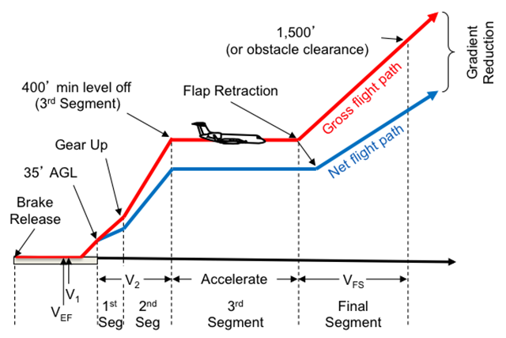

NTFP

|  |  |  |  |  |
| --- | --- | --- | --- | --- |
| Class A Gross Climb Gradient | | | | |
|  | 1st Segment | 2nd Segment | 3rd Segment | 4th Segment |
| Gradient for 2 Engines | > 0 % | > 2.4 % | > 1.2 % | > 1.2 % |
| Gradient for 3 Engines | > 0.3 % | > 2.7 % | > 1.5 % | > 1.5 % |
| Gradient for 4 Engines | > 0.5 % | > 3.0 % | > 1.7 % | > 1.7 % |

|  |  |
| --- | --- |
| Class A Net Climb Gradient (0.6 + # engines %) | |
| Gradient for 2 Engines | Gross + 0.8 % |
| Gradient for 3 Engines | Gross + 0.9 % |
| Gradient for 4 Engines | Gross + 1.0 % |

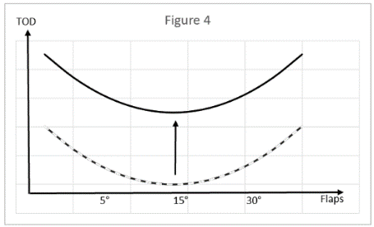Effect of engine out on TOD during takeoff

**Climb**

**Crossover altitude**: when speed during climb changes from constant IAS to constant Mach and vice versa for descent

IAS = ρ * TAS

Cost Index = aircraft operating cost / fuel cost [it is a number between 0-200]

HIGH Cost Index: HIGH speed & HIGH fuel burn

LOW Cost Index: LOW speed & LOW fuel burn

Low cost index will result in:

* lower climb speed
* lower cruise speed
* higher cruise altitude
* later descent
* slower descent speed

**Cruise**

Long range cruise speed:

* is slightly higher than the Maximum range speed, so it requires a higher Cost Index.
* gives a specific range which is ~ 99% of maximum specific range and a higher cruise speed but allows for an increase in cruise speed of 4%.

Minimum fuel consumption is given by the Maximum range speed

Step climb is used to increase range and is usually done to climb in a 2000 ft block.

Performing a step climb based on economy, it can be limited by the 1.3g buffet onset

Experiencing buffet at the aerodynamic ceiling (coffin corner) it is recommended to reduced thrust, maintain IAS and descent. Any increase or decrease in IAS could increase the buffet

Specific range = NM/kg

**OEI cruise**

Drift Down procedure entails setting maximum continuous power/thrust (MCT) on the operating engine(s). it is done when cruising at an altitude above the optimum OEI altitude.

Drift down strategy: fly at VMD (obstacle clearance speed | least rate of sink | best OEI angle of climb) to increase obstacle clearance

Level off altitude is dependent on engine(s) thrust and OAT

**Approach and landing**

Prop: LD x SF = LDA x 0.7 LDR = LD x 1.43 x SF

Jet: LD x SF = LDA x 0.6 LDR = LD x 1.67 x SF

VREF > 1.23 VSR0

VSR0 is a speed at or above the speed an aircraft reaches CLMAX in the landing configuration with a load factor equal to 1

Landing in a wet runway: positive (firm) landing + full use of autobrake with antiskid + reverse thrust + retardation devices

Maximum quick turnaround mass: if landing above it, a certain time should pass for brake cooling before the next takeoff

With ↑ OAT, MLM ↓ as GS ↑

Balked landing climb gradient requirement [all engine operating]:

* class A: 3.2%
* class B: 2.5% [0.75% OEI]

In the landing roll brakes can be applied when both main gears are on the ground AND provided that the nose gear can be lowered in a controlled manner

Approach Climb (-0.3%)

2 engines = 2.1%

3 engines = 2.4%

4 engines = 2.7%

**CS-25/Applicable Operational Requirements Performance Class A – Use of airplane performance data**

Climb limited takeoff mass is independent of wind.

The climb angle relative to the ground will be affected by wind